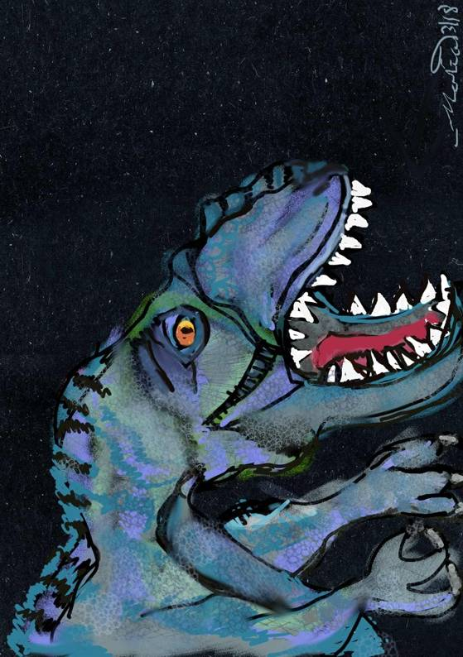Blem.

C:\Users\Ray\Desktop\laManoMalvadita\The Dinosaur Game\TrashcanLogo.tif

The Trashcan

**Software and Media Publication**

Computer Game Design Document and Development Log

|  |
| --- |
| The Dinosaur Game Development Team  9 February 2018 to Future Date |

The Dinosaur Game

|  |
| --- |
| The Trashcan (Software and Media Publication, NFP) |
| The Dinosaur Game |
| Computer Game Design Document and Development Log |

|  |
| --- |
| The Dinosaur Game Development Team  9 February 2018 to Future Date |

All text herein, software described, music, and visual artwork Copyright © 2018 Raymond Arias, Jr. and Maria A. Arias (and where applicable, Stanton J. Viaduc).

Although a number of nonproprietary licenses are being considered for the release of the final work, none of these licenses apply at this stage.

Neither the authors, nor their agencies nor nonprofit corporations, as connected to this document, such as Arias Concepts & Services or The Trashcan Software and Media Publication, are liable for any unauthorized and/or improper use of these materials.

**Development Team Guide**

**Name in Document** **Full Name** **Roles in Development**

Ray Raymond Arias, Jr. Developer of Original Version, Primary Developer of New Version, Primary Author of this game document, Direction, Artwork, Coding

marias María A. Arias Development Consultant, Artwork, Visual Consultant, Other Roles To Be Determined

Stan Stanton J. Viaduc Development Consultant, Other Roles To Be Determined

Contents

OOO. Development Team Guide……..…………………………….……………………… 5

OO. Table of Contents……………………………………………....…………………….….6

O. Table of Illustrations………………………………………………………………………..7

I. History 10

A. Original 1986 Game Look 10

B. Original Game Music 11

C. Original Game Play 12

1. Description in Prose 12

2. Pseudocode 13

D. Original Game Story 16

II. Planning for Development of Prototype 17

A. Basic Plan for Proto type 17

B. Filling in Pseudocode to Recreate TOG 17

III. Conceptual Development of Newer Modernized Game 18

A. Discussion of Possible Change to Game Title 18

B. Ideas to Fill in the Story 19

1. First Stage/Volume One 19

2. Second Stage/Volume Two 20

3. Third Stage/Volume Three 21

Appendix 1: Development Log 22

**Illustrations**

Figure 1: Initial screen of original 1986 version of The Dinosaur Game, recreated from memory by Ray using Windows Paint. 10

Figure 2: Sketch of Giganotosaurus digitally drawn with Autodesk Sketchbook and GIMP (GNU Image Manipulation Program) by marias. 11

Figure 3: Recreation of game play screen from TOG with the path of the spear shown, digitally drawn using Windows Paint from memory by Ray. 12

Figure 4: Rough sketch for the game, digitally drawn using Iskn Slate2 by Ray. 16

Figure 5: Screen capture showing the result of Ray's first successful compilation of C++ code using the program library SDL 2.0.8. 18

Figure 6: Preliminary sketch for the game, digitally drawn using Autodesk Sketchbook by marias. 19

1. History
2. Original 1986 Game Look

The current design of this game is based on a simple game that Ray made in 1985-6 on a Commodore 128 in Microsoft Commodore BASIC 7.0 and 8502 machine code using the built in machine language monitor. There are absolutely neither any soft- nor hardcopies of any code, screens, or design for this original game. The only source for information about this game is Ray’s memory of it. Any reference to this game in this document will be labeled TOG for “The Original Game.”

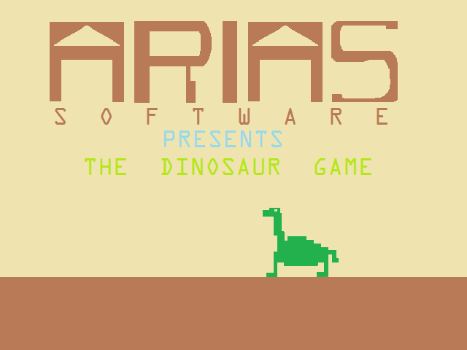TOG had a start screen with a dark brown ground comprising about the bottom fifth of the screen, a yellow background making up the remainder of the screen and a green dinosaur with a Brontosaurus/Apatosaurus appearance walking across atop the ground from right to left with deep percussive tones played with every step. The size of this dinosaur was approximately a fifth of the screen vertically and a seventh of the screen horizontally, and it was physically about as tall from head to foot as it was long from head to tail. Displayed at about mid-height of the start screen were large letters saying “ARIAS” and under these were medium letters spaced to fit the horizontal space taken up by the large letters saying “S O F T W A R E” and under this were more medium letter saying “Presents THE DINOSAUR GAME.”

Figure 1: Initial screen of original 1986 version of The Dinosaur Game, recreated from memory by Ray using Windows Paint.

1. Original Game Music

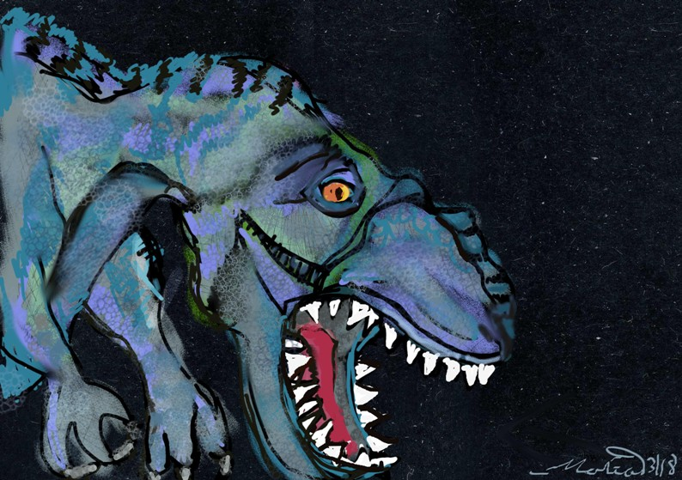The music for TOG was played with the three-voice VIC sound chip in two of its three voices. The lower voice was an organ and the higher voice was a guitar. 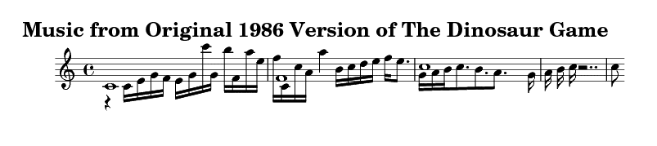

Figure 2: Sketch of Giganotosaurus digitally drawn with Autodesk Sketchbook and GIMP (GNU Image Manipulation Program) by marias.

1. Original Game Play
2. Description in Prose

TOG began when the fire button on the joystick was pressed and displayed a dark blue screen with a brown ground bottom in the same position it was in the start screen. The player was displayed on the left side of the screen as a white human-looking figure with what appeared to be a spear in its hand. In the bottom, lettering was displayed as a message line by line to the player explaining the game story (see next subsection, D. Original Game Story), until either the fire button was pressed again or 10 seconds passed after the final line of text. Then a long tone ascending in frequency would be played and, when the tone rose to top pitch, the same yellow background with a brown bottom as the start screen would be displayed, and another descending tone starting at high frequency would be played. When the tone lowered to its bottom pitch, the dinosaur would appear all the way on the right edge of the screen and play would begin at 3 lives and first level.

When the joystick was left alone, the player figure would stay still and the dinosaur figure would proceed left toward the player at a certain speed. (At Level 1, this speed was about 5 pixels a second, but this speed would increase at higher levels.)

When the joystick was pushed left, the player figure went about 20 pixels to the left, up to the left edge of the screen.

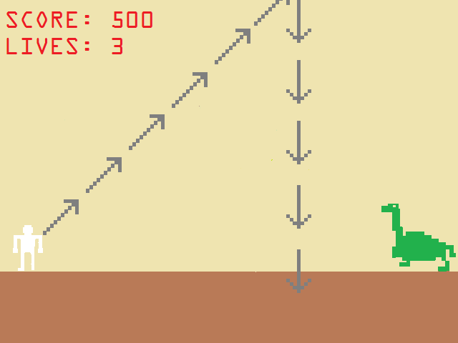When the joystick was pushed right, the player figure went about 20 pixels to the right, theoretically up to the right edge of the screen, although because the dinosaur was inevitably in the way, this typically was not possible. (Sometimes, a glitch early on in the development of TOG would actually make this possible because the routine that detected whether the player and dinosaur collided would not run fast enough—you gotta love Commodores running BASIC—before the player passed to the other side of the dinosaur. However, this issue was later solved by matching the X position of both the player and the dinosaur in such a way that if the X position of the player was greater than or equal to the X position of the dinosaur, the routine that causes the player to die would execute. However, this method of detection was used concurrently with the traditional collision detection method, as opposed to in place of it.)

Figure 3: Recreation of game play screen from TOG with the path of the spear shown, digitally drawn using Windows Paint from memory by Ray.

Pushing the joystick up or down, while early on in development of TOG had no effect, later had the effect of allowing the dinosaur to proceed somewhat faster during the time the joystick was pushed either up or down. When the joystick was released from the up or down position, the dinosaur would again proceed at its original speed.

When the fire button was pressed, a spear coming from the player’s position would be released and travel at 45° counterclockwise from the horizontal until it got to the top of the screen, at which point the spear would appear to turn 135° clockwise, such that it proceeded straight downward. If the spear did not hit the dinosaur, play would continue as before. However, if the spear did hot the dinosaur, the dinosaur would vanish, the player would be advanced to the right until the player figure wrapped around to the left side again (in what was presumably another scene, but appeared to be the same) and would stop at the same position it was at the beginning of the first level, another dinosaur would appear at the right edge of the screen, and play would start again at a new level.

1. Pseudocode

void DisplayStartScreen() {

DisplayTitleAndBackground;

PlayThemeMusic;

int XPositionDinosaur = RightEdge;

int DinosaurFigure = 1; /* There are 4 dinosaur figures according to what position the Dinosaur’s feet are in */

while (FireButtonNotPressed) {

while (DinosaurFigure <= 4) {

DisplayDinosaur(DinosaurFigure, XPositionDinosaur);

DinosaurFigure++;

XPositionDinosaur -= 5;

if ((FireButtonNotPressed) &&

(XPositionDinosaur <= LeftEdge))

XPositionDinosaur = RightEdge; }

Dinosaurfigure = 1; }

StopThemeMusic;

return; }

void GamePlay() {

DisplayStoryBackground;

While (FireButtonNotPressed)

for (int StoryLine = 0; StoryLine <= LastLineOfStory; StoryLine++) DisplayStoryLine(StoryLine);

DisplayStandardGameBackground;

int Level = 1;

int Score = 0;

int Lives = 3;

int XPositionPlayer = LeftEdge;

int XPositionDinosaur = RightEdge;

int DinosaurFigure = 1;

int PlayerFigure = 2; /* There are 3 player figures according to if the player is standing still (PlayerFigure = 2), moving to to the left (PlayerFigure = 1), or moving to the right (PlayerFigure = 3). */

bool PlayerAlive = TRUE;

bool DinosaurAlive = TRUE;

DisplayPlayer(XPositionPlayer, PlayerFigure);

while ((Level < MaxLevel) && (Lives > 0)) {

while ((DinosaurAlive) && (PlayerAlive)) {

if (NoJoystickMovement) || (JoystickUp) || (JoystickDown)) {

PlayerAlive = (XPositionPlayer < (XPositionDinosaur - MarginOfError));

if (DinosaurFigure <= 4) {

DisplayDinosaur(XPositionDinosaur, DinosaurFigure);

DinosaurFigure++;

XPositionDinosaur -= 5;

if (NoJoystickMovement) Wait(Level);

else if (Level < (MaxLevel – 2))

Wait(Level + 2);

else Wait(MaxLevel); }

else DinosaurFigure = 1; }

else if ((JoystickLeft) || (JoystickDiagUpLeft) || (JoystickDiagDownLeft)) {

PlayerAlive = (XPositionPlayer < (XPositionDinosaur - MarginOfError));

int InitPlayerPosition = XPlayerPosition;

int FinalPlayerPosition = XPlayerPosition – 5;

if (FinalPlayerPosition < LeftEdge)

FinalPlayerPosition = LeftEdge;

PlayerFigure = 1; /* Facing left */

while (XPositionPlayer > FinalPlayerPosition) {

XPositionPlayer--;

DisplayPlayer(PlayerFigure, XPlayPOsition);

}

}

if ((JoystickRight) || (JoystickDiagUpRight) || (JoystickDiagDownRight)) {

PlayerAlive = (XPositionPlayer < (XPositionDinosaur - MarginOfError));

int InitPlayerPosition = XPlayerPosition;

int FinalPlayerPosition = XPlayerPosition + 5;

PlayerFigure = 3; /* Facing right */

while (XPositionPlayer < FinalPlayerPosition) {

XPositionPlayer++;

DisplayPlayer(PlayerFigure, XPlayPOsition);

}

}

else if (FireButtonPressed) {

int YPositionSpear = Ground;

int XPositionSpear = XPositionPlayer;

bool DinoHit = FALSE;

bool SpearFigure = FALSE; /* There are 2 spear figures, one for shooting up at 45 deg angle and one for going straight down */

for (int YPositionSpear = Ground; YPositionSprear > TopOfScreen; YPositionSpear--) {

XPositionSpear++;

DisplaySpear(SpearFigure, XPositionSpear, YPositionSpear); }

SpearFigure = TRUE; /* Switch to falling spear */

For (int YPositionSpear = TopOfScreen; YPositionSpear < Ground; YPositionSpear++)

DisplaySpear(SpearFigure, XPositionSpear, YPositionSpear);

DinoAlive = !(Abs(XPositionSpear – XpositionDinosaur) <= 7); }

}

if (PlayerAlive) { /* Dinosaur dead */

KillDinosaur;

Score += 100;

Level++;

GoNewLevel; }

else { /* Player dead */

KillPlayer;

Lives--; }

}

if (Level == MaxLevel) ShowEndGameGraphics;

return; }

main() {

while(1) {

DisplayStartScreen();

GamePlay(); }

}

1. Original Game Story

TOG’s story was displayed just before game play began. It was written in the second person (speaking as an unidentified narrator referring to the player as “you” giving exposition directly) and was displayed approximately as follows:

YOU ARE A SPECIAL AGENT FOR THE SUPER-SECRET CENTRAL INTELLIGENCE AGENCY (SSCIA). EXTREMELY INTELLIGENT DINOSAURS FROM MILLIONS OF YEARS AGO HAVE INVENTED TIME MACHINES AND ARE USING THEM TO TRAVEL TO THE PRESENT DAY IN ORDER TO KILL OFF ALL HUMANITY AND TAKE OVER THE MODERN WORLD IN ORDER TO ACQUIRE ALL OUR TECHNOLOGY AND INFRASTRUCTURE. THE SSCIA IS SENDING YOU BACK INTO THE DINOSAURS’ ORIGINAL TIME TO ANIHILATE THESE DINOSAURS BEFORE THEY TRAVEL FORWARD IN TIME. YOU MUST USE YOUR ANNIHILATION SPEARS TO TELEPORT THEM INTO OBLIVION BEFORE THEY DEVOUR YOU. THE AGENCY HAS ACQUIRED ONE OF THE DINOSAURS’ TIME MACHINES FOR THIS PURPOSE. PREPARE FOR TRANSPORT.

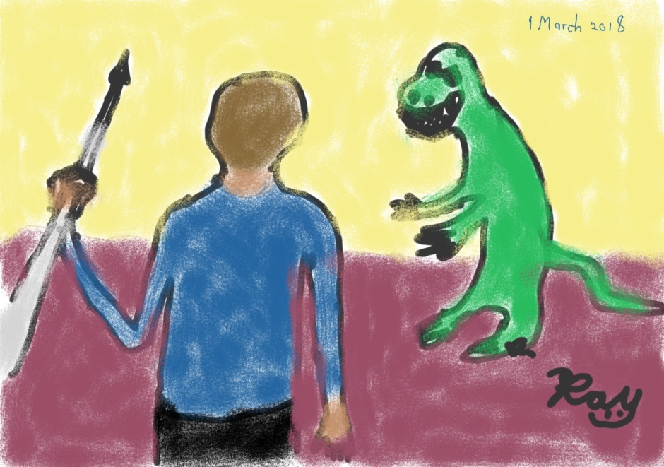The basic notion behind the original story is that many dinosaurs were way more intelligent, civilized, and organized than we gave them credit for. Apparently, some of them have developed a method to travel in time and have used it to carefully and inconspicuously travel into the future until they happened upon our time and became envious of all our technology that they desire in order to add to their own. The role of the player is to defeat the dinosaurs before they are able to make this happen. Certain points of background are not explained in the game, such as if the dinosaurs already have their own technology that is advanced enough to travel in time, why would they still desire human technology, and how exactly was the SSCIA able to acquire one of the dinosaurs’ time machines and somehow adapt it for human use. Also, obviously, the name of the secret agency (“the Super-Secret Central Intelligence Agency”) wasn’t very well considered before it’s placement in the story. These are all issues that need work when modernizing the game.

Figure 4: Rough sketch for the game, digitally drawn using Iskn Slate2 by Ray.

1. Planning for Development of Prototype
2. Basic Plan for Proto type

The Prototype for the new version of the Dinosaur Game (labeled as TNG for The New Game—not to be confused for the television series *Star Trek: The Next Generation*, sorry, nerd joke.) will eventually be developed in the Unity game engine, but will begin as a restoration project of TOG using ,SDL (Simple DirectMedia Layer) 2.0.8, except the title screen will be slightly different. From there, modernized digital artwork by Ray and Maria will be used for backgrounds and movable sprite figures (aka assets in Unity). Further, although the spear will at first generally function as it did in TOG for the initial prototype of TNG, in later stages if prototype development, the spear is to look and fly on the screen much like a real spear would in a parabolic trajectory, rotating through the motions of facing diagonally upward at first when it is initially fired, facing perfectly horizontal at the vertex of the trajectory, and finally facing diagonally downward as it nears its destination.

1. Filling in Pseudocode to Recreate TOG

Recreating and developing TOG is to be as much for the purpose of exercising this Development Team in software coding as much as it is for the purpose of creating a game prototype that will eventually become TNG, the modernized version of The Dinosaur Game. With this in mind, there will be numerous versions of TOG coded in various languages and making use of different software engines and libraries and even different compilers for the same language. We can use this as a change to review our skills in coding and developing as well as to see what resources are out there and available for us to use, not to mention which resources work best in specific situations.

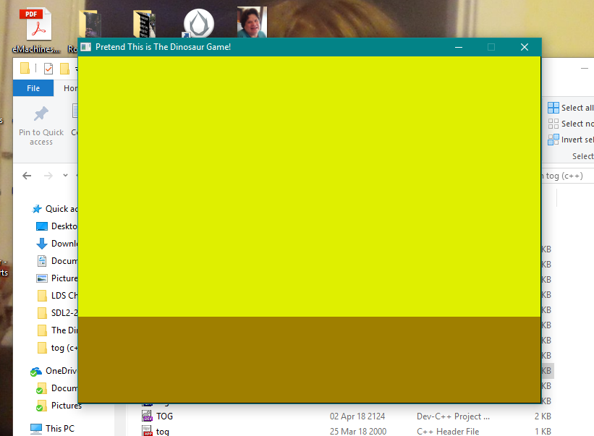To begin, Ray will first take the TOG pseudocode and begin converting it to C++ code for use with the SDL 2.0.8 Library for compilation with GCC. From here, many versions of the game can be made using various languages and environments.

Figure 5: Screen capture showing the result of Ray's first successful compilation of C++ code using the program library SDL 2.0.8.

After many frustrating misadventures learning how to appropriately integrate SDL 2 into the IDE package Dev-C++ and how to appropriately include the SDL into the program code, including one four-day long stalemate when nothing would compile because of the use of “SDL_INIT()” when attempting to call the function “SDL_Init(),” Ray finally successfully compiled and run his first C++ program using the SDL library rendering the window shown in this section on 3 April 2018.

1. Conceptual Development of Newer Modernized Game
2. Discussion of Possible Change to Game Title

Ray and Maria, in personal conference with each other, have discovered that there are numerous games in existence about dinosaurs in one context or another, with titles all featuring the word “dinosaur.” With this in mind, the thought occurred to Maria that a game with such a generic title as “The Dinosaur Game” may get lost in a Google search or even just a search on Google Play for an Android app, which is one of the forms this game may be developed into. In context of the some of the details of the game story in development (see the next subsection, C. Ideas to Fill in the Story) it was agreed that one possible alternative for a title would be “The Time Traveling Dinosaur Apocalypse.” However, Ray has decided not to finalize this change just yet (by changing the title of the game document, the name the GitHub depository, the names of all the file folders/directories, the filenames themselves, etc. as this would entail some deal of effort and if the name should change again, even more effort would have to be expended, also, keeping all the code and records under different changing names, particularly names of depositories, directories, and files would also cause confusion as to where to find everything. Therefore, while the devilment team will keep in mind that the final name of the game may change, its working title throughout the duration of this project will be “The Dinosaur Game.”

1. Ideas to Fill in the Story

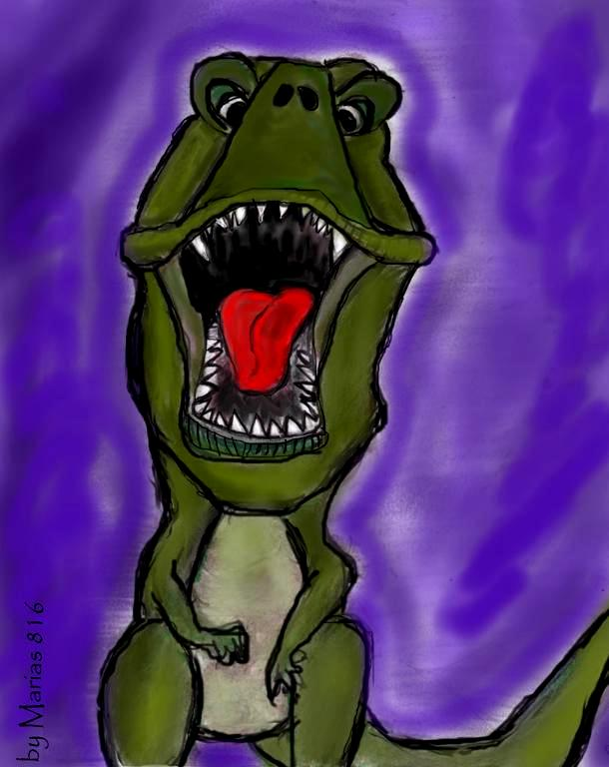Ray has come up with more ideas to fill in the game story. They are as follows.

1. First Stage/Volume One

You (aka the player) are a secret agent, with a specific name and agency (real or fictional) to be determined, tasked with an assignment of going back in time to 82,356,743 BC to eliminate intelligent dinosaurs before they travel forward in time and attempt to dominate the modern world. The time travel mechanism used to bring you back in time was developed by these intelligent dinosaurs and was adapted by the agency for use by humans. You will be eliminating the intelligent dinosaurs by throwing SPEARs, or Stick Projectile Eradication and Annihilation Receptacles. Essentially, these are miniature time traveling devices developed by the agency using the technology initially developed by the dinosaurs. They teleport anything they hit, but instead of sending it to a specific time and place, they send it into an abysmal void where nothing exists. Be very careful, these dinosaurs are very intelligent and can outsmart you at any moment. Your first skirmishes will take place on land, and initially your opponents will also be on land, but soon intelligent pterosaurs will join them from the air. Also, initially the terrain will be continuously solid ground, but later on there will be gaps filled with water and lava, as well as hills, mountains, and volcanoes, so watch out. Later battles of this first stage will also be fought in the sea with giant aquatic ancient animals, that are also intelligent, and in the air with more pterosaurs and dinosaurs in giant flying vehicles (the dinosaur equivalent of fighter jets).

Figure 6: Preliminary sketch for the game, digitally drawn using Autodesk Sketchbook by marias.

1. Second Stage/Volume Two

A well-educated, misunderstood and alienated genius from a very rich family who works in animal genetics discovers a giant metallic pod in the woods while hiking one day. S/he (Ray hasn’t determined this person’s gender yet) goes inside and finds a bunch of large foot-petal controls and a three-ring binder with hand-written notes in English telling him/her what the controls do along with suggestions to use this pod device to travel back in time to the time of the dinosaurs to bring back specimens to experiment on. At the end, the notes are signed, “Your Secret Friend.” Also there’s a post-script that reads, “P.S. Whatever you do, hide this time travel pod in your garage and don’t tell *anyone* about it! They won’t understand and you can get into a *lot* of trouble. I know, *I* almost did!”

At first s/he hides the time travel pod in his/her garage, but later s/he builds a secret lab and hides the pod in it. As time goes on, this person carries out many experiments using combinations of dinosaur and modern animal DNA. S/he has a collection of very strange and bizarre animals from monkeys that roar like dinosaurs to tree hopping dogs that can glide through the air. Eventually, s/he comes up with intelligent dinosaurs that can speak.

Some of the dinosaurs tell him/her that they want to leave the lab and go explore, but s/he can’t let them do that because then his/her secret will be out, so as a compromise, they agree to use the pod to go back into the time of the regular (not-so-intelligent) dinosaurs, where they will fit in with their own kind. This person is sad to see his/her friends go, and take the only time traveling device s/he has ever used with them, but knows there is no other solution to this problem. There is also another issue. There is only room enough for one dinosaur, maybe two small ones at the most, in the pod. However, this issue is mysteriously solved as ten more pods spontaneously appear in the lab with a note saying “Compliments of Your Secret Friend!” There is even an extra, mini-pod (human sized, with controls made for human hands) for this person to use after all the dinosaurs leave.

Soon the agency discovers what this person has done and they want to stop him/her from creating the intelligent dinosaurs, so they send a message to the directors of the agency in the past when the person started experimenting and hadn’t made the dinosaurs intelligent yet. You are the main agent sent over to arrest and stop him/her. S/he evades capture and unleashes all his genetic monstrosities to come get you and wreak havoc upon the world. At first, the land animals come for you (with some help from flying ones) and you must send them into oblivion with your SPEARs. Next, this person lets loose all his/her marine abominations into the sea, and you must conquer them as well. Finally, an air battle ensues with the flying beasts again before you must defeat the enemy him-/herself.

1. Third Stage/Volume Three

One day in Pennsylvania 1723, a man discovers a large bag of gold nuggets on his farm along with a note where to mine for more. The great, great grandson of this man, a minor stockbroker in New York 1929, finds a note in his desk telling him to sell all his gold and invest in a series of short positions in stocks just before the stock crash that commenced the Great Depression. Both of these notes were signed, “Your Secret Friend.” The stockbroker ends up making millions of dollars from this trade. With this money, the stockbroker starts his own successful brokerage firm, making even more money. This broker was the grandson of the mad scientist. The agency eventually hears about these incidents and discovers that the parents of the mad scientists are involved as well as some intelligent dinosaurs. You are sent to defeat the dinosaurs, and after them, the parents themselves.

# Appendix 1: Development Log

Date Name Development Work

9 February 2018 Ray Game Document commenced

12 February 2018 Ray Section I. History written

15 February 2018 Ray Google Docs folder created and shared with Stan, files initially uploaded

20 February 2018 Ray GitHub repository opened and files initially uploaded

20 February 2018 Ray Game Document copied to GitHub Wiki

23 February 2018 Ray Section II. Planning for Development of Prototype commenced

24 February 2018 Ray Subsection II A. Basic Plan for Prototype written

24 February 2018 Ray Subsection II B. Discussion of Possible Change to Game Title written

24 February 2018 Ray Subsection II C. Ideas to Fill in the Story commenced

26 February 2018 Ray Began opening issues in GitHub to begin organizing work on game

26 February 2018 Ray Appendix 1: Development Log commenced

26 February 2018 Ray Subsubsection II C 3. Third Stage/Volume Three written

1 March 2018 Ray Digitally drew rough sketch for game and placed into Document

2 March 2018 Ray Drawing by marias copied into project files and placed into Document

2 March 2018 Ray Updated issues and Wiki on GitHub

8 March 2018 marias Created drawing of giganotosaurus

9 March 2018 marias Created drawing of Apatosaurus

16 March 2018 Ray Inserted marias’ drawings into document

16 March 2018 Ray Inserted new logo for The Trashcan and cover art for Game Document and Development Log

17 March 2018 Ray Showcased cover art on black page (black rectangle in background made the size of the page)

24 March 2018 Ray Edited pseudocode file saved as TOG.pseudo and converted code to conform with C++ standards and saved as TOG.cpp

25 March 2018 Ray Researched Windows- and Android-compatible graphics libraries and chose SDL 2.0 for encoding and testing TOG.

26 March 2018 Ray Broke Section II. Planning for Development of Prototype Into two sections consisting of above and Section III. Conceptual Development of Newer Modernized Game.

3 April 2018 Ray First successful program compiled and run giving window rendering TOG background. (Insert your favorite version of Leonard Cohen’s “Hallelujah” here; Praise Satan!)